**Resources for Session 7**

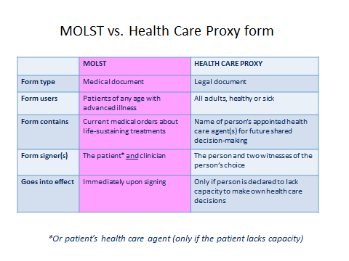

**Helpful Links:**

<https://respectingchoices.org/wp-content/uploads/2020/12/Proactive-Care-Planning-Conversation-COVID-19_12.20.pdf>

<https://www.vitaltalk.org/covid-resources/>

<https://www.optimistic-care.org/probari/covid-19-resources>

<https://www.nytimes.com/2020/12/10/technology/pfizer-vaccine-infertility-disinformation.html>

<https://www.asrm.org/globalassets/asrm/asrm-content/news-and-publications/covid-19/covidtaskforceupdate11.pdf>

<https://www.youtube.com/watch?v=Dnnu43Zt-oA>