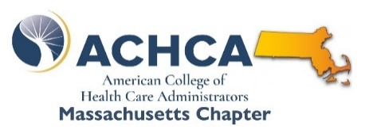
Echoes from Administrators

ACHCA MA Chapter welcomes practicing administrators to an ongoing virtual community of peers leading facilities across the Commonwealth.
After over two years of constantly changing demands from every corner, you are invited to convene with an opportunity to hear what colleagues have happening in their buildings.
We gather virtually!

Kickoff session is open to all MA LNHA’s!

Cost: FREE! NHA CEU’s: 1.0

Next Date: Wednesday, November 9th at 2PM.

Pre-registration is required – [click here] – a meeting link will follow.

Scan to register.

Content Areas Include
Our Survey & Regulatory Experiences  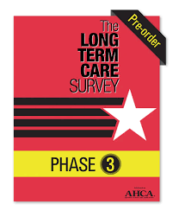 | - Unexpected surveyor focuses and approaches  - How phase III changes seem to be impacting survey and outcomes and surveyor behavior  - When problems have come up, how they were handled

Our Workforce | - Hires? What’s it taking?  - Retention  - New expectations that seem to be influencing decisions to stay/go? Any successful interventions?  - Agencies?  - What are they presenting?  - Any relief from some of their most egregious issues?

Reimbursement / Financial | - Facility-level considerations specific to rate components?  - MMQ Audit Activity?  - MassHealth Eligibility, Application, Denials and Appeals Experience?  - Medicare – ADR’s and other post payment audits?  - Private Insurers and Managed Care experiences.  - Expense Management Initiatives that Work (and Don’t)  - Admissions/Discharges and Census

\ACHCA\Echoes Administrators - 20221109.docx

